<INSERT LOGO>
Business Continuity Management Plan
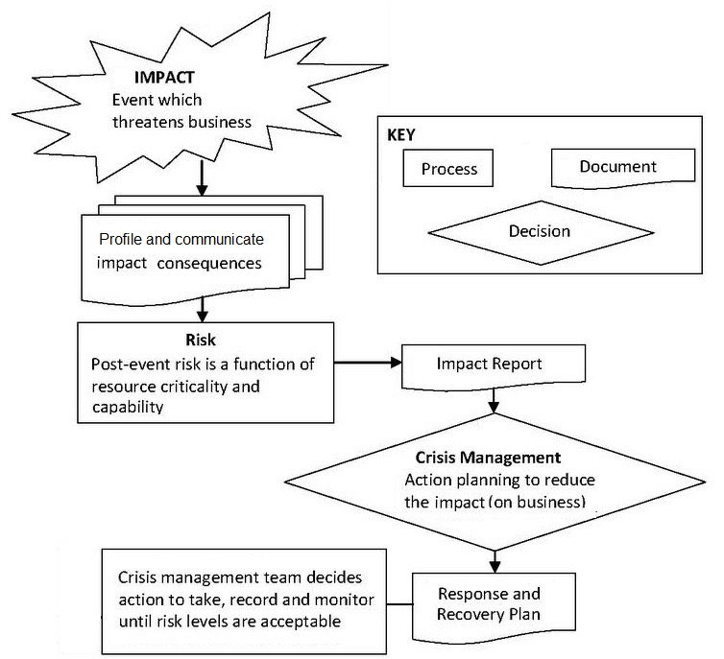

<INSERT CLIENT NAME>
<INSERT DATE>

Document Control Information

Details
Title | <INSERT CLIENT NAME> Business Continuity Crisis Management Plan
Plan No. | 1.0
Date of first version
Filename
Storage Location | Fiverr Delivery

History
Version | Date | Author | Comments
1.1 |  | John Salter | First Draft
1.2
1.3

Approvals
I approve that this document be accepted as the Business Continuity Plan – Crisis Management
Version | Date | Name | Position | Signature
1

Responsibility
I accept responsibility for the review, maintenance and distribution of this document.
Version | Date | Name | Position | Signature
1

Review frequency
This document should be reviewed and approved every two years or whenever there is a significant change in circumstances within the organisation

Frequency of review | Date for next review exercise
At least every 2 years.  Or whenever the circumstances of the business change. | Planned for – Feb / 2021

Table of Contents
Table of Contents 3

Terms used - and their meanings 4

Introduction – key ideas underpinning the Plan 5

Attachment A: Agenda - Crisis Management Team meeting. 7
Damage assessment 8
Recovery contacts 9
Temporary Office Accommodation 10
Data security & backup strategy 10
Expected cash flow 11

Attachment B: PRE-IMPACT PLANNING DOCUMENTS 12

Attachment C: WORKFLOW – Initial Response, Continuity, Recovery and Review Phases 17

Terms used - and their meanings
This Table specifies the meanings of terms as used in this document.
Business Continuity | Temporary restructuring of the organisation by the Crisis Management Team to achieve agreed objectives.
Crisis Management Team | The Crisis Management Team provides oversight of strategic decision making and communication with key stakeholders.
Event or Disruption Event | Any condition or circumstance which threatens continuity of business.  It is important to note what that this does NOT mean. It does not mean the “normal” range of minor operational glitches (such as Service Level Agreement variations) which are part of the workplace and do not threaten the organisation’s capability to deliver on its key obligations.
Preparedness | This plan is based on the principle that sound information reduces uncertainty and improves decision making.
Resources | People; skills; information (electronic and non-electronic); premises; supplies (including external contractors and providers of inputs to processes – e.g. fuel, power, water); and technology (including plant and equipment).  Resources are the critical focus of this plan because they underpin the capacity of the organisation to deliver services.
Maximum Acceptable Outage | The maximum acceptable time that a service can be out of commission.

Introduction – key ideas underpinning the Plan
Overview
This Business Continuity Plan documents description of the actions to be taken, resources to be used and the procedures to be followed before, during and after an event that significantly disrupts all or part of core business. The Plan has been built on a risk based, structured methodology.
Objective
The goals of the Plan are:
- minimise the duration of business interruption
- facilitate effective decision making during a business interruption
- ensure an orderly resumption of acceptable business operations
Scope
The Plan can be used to manage coverage of Partial or Major interruption:
- From all hazards (e.g. Fire, Floods, Earthquake, Disease, Storm, and Terrorism)
- To any resources (e.g. Information systems, Utility Outage, Supply Chain, and Key staff)
The likelihood of occurrence of any of the above mentioned extreme trigger events is not in the scope of this document.
The focus of this approach is on the availability of key resources – to maintain operability.
Planning Process
The development - and maintenance - of the Plan has included:
Business Impact Analysis - In this phase, CRITICAL ACTIVITIES that are critical to the support of KEY PRODUCTS / SERVICES are identified. This list is recorded on the appropriate worksheets and, over time, will be further detailed and exported to the Excel tool. In short, the following were identified:
- <INSERT>
Decision making - The Crisis Management Team will focus on four primary decision points:
- What has happened - what are the risks (detection),
- what do the risks mean (recognition and interpretation),
- who needs to know what (communication to multiple stakeholders), and
- who needs to do what (organization of a collaborative system).
The plan is based on using Business Impact Analysis for Damage Assessments.
This will provide a sound basis to inform crucial decisions by the Crisis Management Team.
Maximum Acceptable Outage
Maximum Acceptable Outage time is the maximum time a service can be out of commission before the effect imposes risks or outcomes which are unacceptable - as agreed by senior management.
This plan focuses on Key Business Processes with a Maximum Acceptable Outage of <INSERT>
The achievement of an “acceptable level of functioning” for any Key Business Process should be advised to the Crisis Management Team by the person responsible for that Key Business Process by updating their Impact Status.
Recovery Time Objective
The Recovery Time Objective (RTO) is the planned time, or target, to restore an acceptable level of service delivery. The RTO will be estimated in Action Planning by the Crisis Management Team and form the basis of determining priority actions. These actions will be tracked on the Master Action Plan.
Note: The RTO should be less than the Maximum Acceptable Outage otherwise restrictions to service levels will apply and those restrictions will therefore need to be managed (communicated to customers). Recovery Time Objectives may also be advised by contract clauses.
Activation
This plan shall be activated by any available member of the Crisis Management Team in the event of any event that in their judgement potentially interrupts ongoing service delivery in a way that puts the organisation at risk. They “declare an event” and “invoke the Business Continuity arrangements”.
Upon activation of this plan the Crisis Management Team shall be formed.
- Crisis Management Team (responsible for decision making);
The Crisis Management Team shall, in the first instance, be made up from any of the available following people:
<INSERT>

Attachment A: Agenda - Crisis Management Team meeting.
This section of the Plan holds summaries and records for use by the Crisis Management Team.

Pre-Start:
- A crisis condition may occur because of an extreme event or uncertain conditions – it may be in geographic, social, political or economic “space”.
- Whoever first detects a crisis condition should address it if they are capable and it is safe to do so, and they should communicate with senior management by whatever methods are effective. Management will then decide whether to assemble the Crisis Management Team (face-to-face or by other means such as Skype).
- Start up
Set up a log of events in an agreed structure (e.g. SMART; “what, who, why, when, how” – see Damage Assessment Table below)
Ensure spouses/partners and families of people involved in the crisis are safe.
Confirm attendance and status of the Crisis Management Team - Confirm leadership.
Clarify the context of this event or circumstances to the extent that “immediately available” information allows you to establish “what has happened” – and “what are the risks”:
- Confirm the adequacy of the initial response.
- Ensure immediate risk to others and business is identified and minimised.
- Reference: The WORKFLOW for the key processes is detailed at Attachment C.
- Communication
Who should be immediately communicated with – internally and externally - and about what?
Tip - Different stakeholders will need to be engaged with in different ways to meet their needs and the needs of the organisation.
Determine which, if any external regulatory and prosecutorial bodies should be notified
- Assess impact
Scope what has happened.
What do we know? What do we not know? What do we need to know?
Get updates of the “dependency data” which will advise the extent of impact / damage assessments
Focus: on OPERABILITY - on key problems and quick solutions.
Identify and rank problems to be solved.
(Rank / Shuffle them as you go – confirm as a closing decision before commitment to action)
Principle: Judge it based on the likelihood of achieving a solution quickly with available resources.

“Recovery – tables to use AFTER impact”

Damage assessment
[Based on damage to your business, complete the table below - shuffle in order of severity.]

Rank | Damage | Impact to business – the problem | Severity | Action | Recovery steps | Resources needed | Actioned by | Estimated date of completion
1 | [List any damage to buildings, assets, stock, documents or surrounding area/community.] | [Describe direct or indirect impacts the damage will have on your business' critical functions.] | [High, Medium, Low.] | [Repair, replace, rebuild.] | [List the steps needed to recover the damage or solve the problem.] | [List the resources needed to solve the problem including any cost estimates, service providers, employees, building materials.] | [Assign someone to each task.] | [Due date for completion.]
2
3

Recovery contacts
[Include organisations/people that will be, or will become, essential to recovery.]
Contact Type | Organisation Name | Contact | Title | Phone/Mobile number
Insurance | [e.g. XYZ Insurance] | [e.g. G. Jones] | [e.g. Claims Advisor] | [(Area code) Number]  [Mobile number]
Telephone/ Internet services provider | — | — | — | —
Bank/building society | — | — | — | —
Employee  (and next of kin) | — | — | — | —
Supplier (Main) | — | — | — | —
Supplier (Backup) | — | — | — | —
Customer | — | — | — | —
Business advisor | — | — | — | —
Accountant | — | — | — | —
Lawyer | — | — | — | —

Temporary Office Accommodation
[“Temporary office accommodation” you can quickly access in an emergency situation.]
Rank | Type | Address | Equipment available | Resources needed
1 | [e.g. Private residence, hotel, temporary business centre.] | [Enter the address of your temporary office site.] | [List all the equipment available at the site. e.g. Computers, furniture, photocopiers, phones, paper] | [List all the resources you will need in order to use this site as a temporary office. e.g. Software, backups, staff, and any other equipment not already available at the location.]

Data security & backup strategy
[How have you protected your data and your network (e.g. virus protection, secure networks and firewalls, secure passwords and data backup procedures)? Detail your backup procedures below.]

Data for backup | Type of data | Frequency of backup | Backup media/ service | Person responsible | Backup procedure steps
[List essential data your business cannot recreate from other sources.] | [e.g. Email, spreadsheet, payroll system data, website.] | [e.g. Daily, weekly, monthly] | [e.g. Tape, CD ROM, external hard disk drive, remote/online backup service.] |  | [List steps required or attach a procedure to the back of this plan]

Expected cash flow

[A large percentage of businesses impacted by a significant disruption fail within a short period. This worksheet cash flow sheet can be developed after impact when implementing your business survival plan]

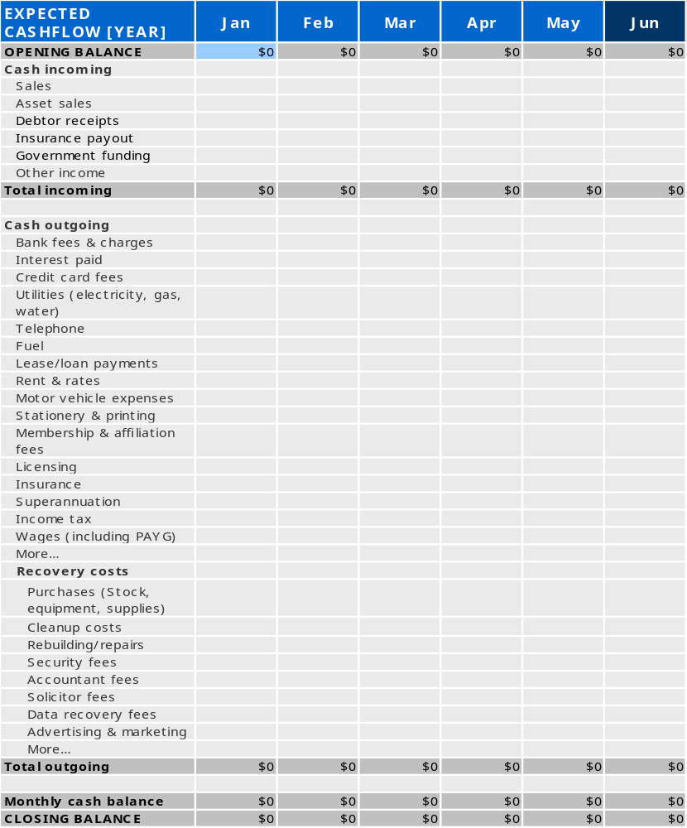

Attachment B: PRE-IMPACT PLANNING DOCUMENTS
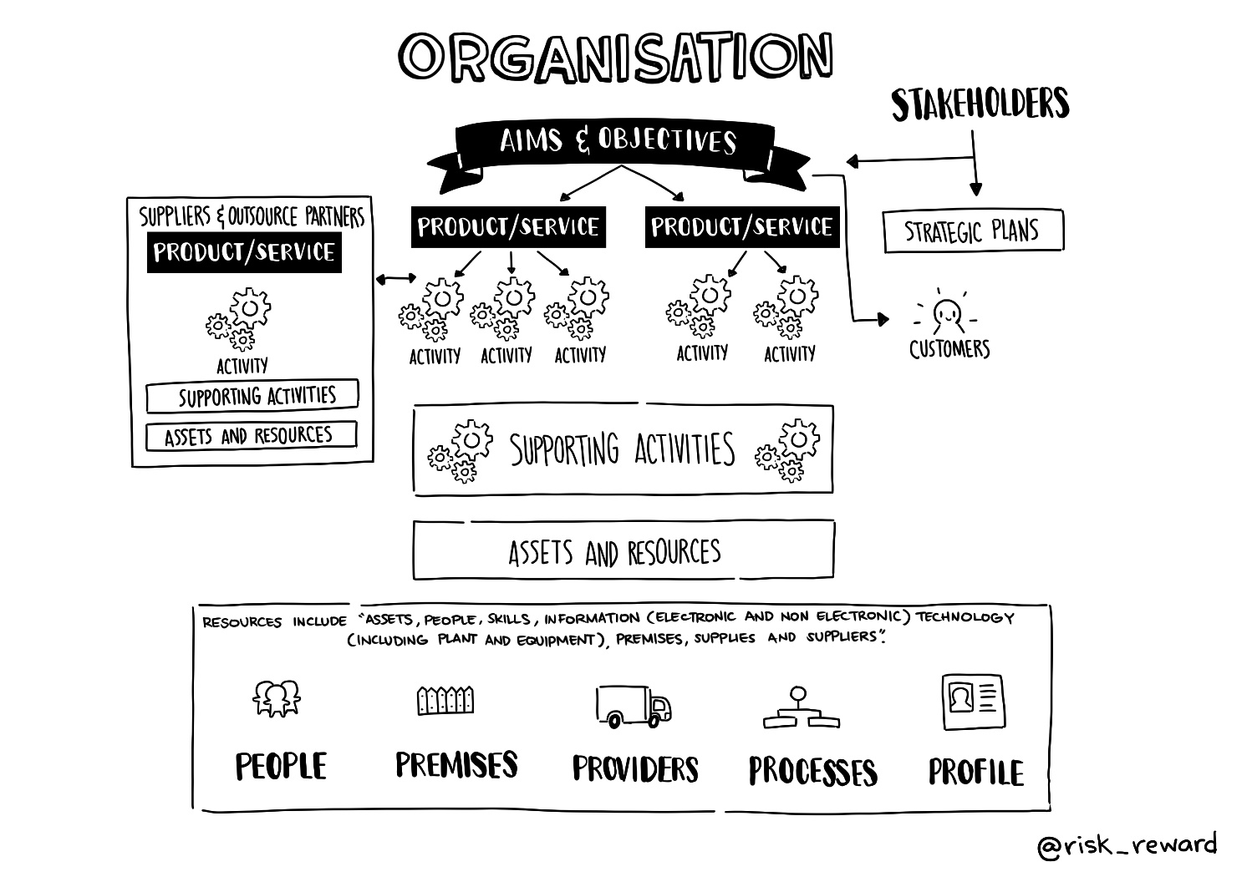
Key Products / Services in priority order.

Key Products / Services  (Described at a High Level and Listed in Priority Order) | Critical Activities underpinning each Key Product / Service /

IF NECESSARY, ADD MORE LINES TO THE TABLE ABOVE TO ENSURE COVERAGE OF YOUR BUSINESS
Using the questions set out below - to prompt our thinking – we have undertaken a concise Business Impact Analysis, filling in our answers, for each CRITICAL ACTIVITY, to the following questions on the blank BIA Sheet under the relevant headings

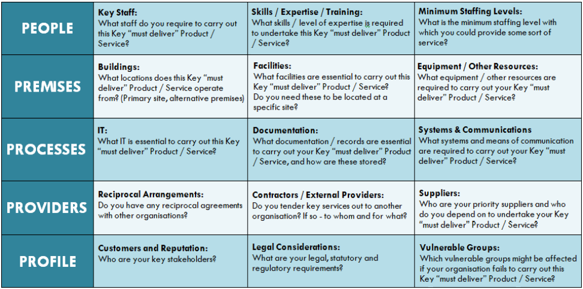

SHEET: BIA PRO - FORMA to be completed for each CRITICAL ACTIVITY
USE ONE SHEET FOR ONE CRITICAL ACTIVITY
(INSERT NAME OF CRITICAL ACTIVITY HERE)

PEOPLE | PREMISES | PROCESSES | PROVIDERS | PROFILE
Key Staff: | Buildings: | IT: | Reciprocal Arrangements: | Reputation:
Skills / Expertise / Training: | Facilities: | Documentation: | Contractors / External Providers: | Legal Considerations:
Minimum Staffing Levels: | Equipment / Resources: | Systems & Communications | Suppliers: | Vulnerable Groups:

The CRITERIA applied to PROFILE the Critical Activities in the Excel tool are tabled below.

CRITICALITY

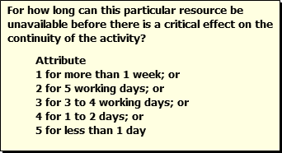

VULNERABILITY

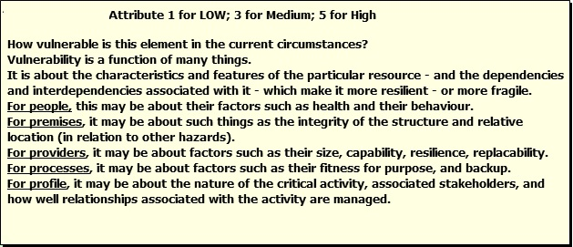

IMPACT

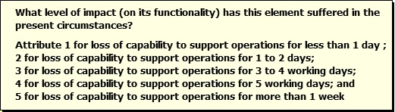

Apply your own KEY / LEGEND
Edit the attributes in the criteria - to reflect your risk appetite

CRITICALITY

For how long can this resource be unavailable before there is a critical effect on the continuity of the activity?

Attribute
1 for more than 1 week; or
2 for 5 working days; or
3 for 3 to 4 working days; or
4 for 1 to 2 days; or
5 for less than 1 day

VULNERABILITY

Attribute 1 for LOW; 3 for Medium; 5 for High

How vulnerable is this element in the current circumstances?
Vulnerability is a function of many things.
It is about the characteristics and features of the resource - and the dependencies and interdependencies associated with it - which make it more resilient - or more fragile.
For people, this may be about their factors such as health and their behavior.
For premises, it may be about such things as the integrity of the structure and relative location (in relation to other hazards).
For providers, it may be about factors such as their size, capability, resilience, replaceability.
For processes, it may be about factors such as their fitness for purpose, and backup.
For profile, it may be about the nature of the critical activity, associated stakeholders, and how well relationships associated with the activity are managed.

IMPACT

What level of impact (on its functionality) has this element suffered in the present circumstances?
Attribute 1 for loss of capability to support operations for less than 1 day;
2 for loss of capability to support operations for 1 to 2 days;
3 for loss of capability to support operations for 3 to 4 working days;
4 for loss of capability to support operations for 5 working days; and
5 for loss of capability to support operations for more than 1 week

The PROFILE of the Critical Activities is represented below.
<INSERT PDFs OR SCREENSHOTS FROM THE EXCEL TOOL>

CONSIDERATIONS FOR INCREASING YOUR RESILIENCE (BEFORE AN EVENT)

Key Staff:  Can staff be contacted out of hours?  Could extra capacity be built into your staffing to assist you in coping during an incident? | Buildings:  Could you operate from more than one premise?  Could you relocate operations in the event of a premise being lost or if access to the premise was denied? | IT:  Is data backed-up and are back-ups kept off site?  Do you have any disaster recovery arrangements in place? | Reciprocal Arrangements:  Do you have agreements with other organizations regarding staffing, use of facilities in the event of an incident? | Reputational Damage:  How could reputational damage be reduced?  How could you provide information to staff and stakeholders in an emergency (e.g. press release)?
Skills / Expertise / Training:  Could staff be trained in other roles?  Could other members of staff undertake other non-specialist roles, in the event of an incident? | Facilities:  Are any of your facilities multi-purpose?  Are alternative facilities available in the event of an incident? | Documentation:  Is essential documentation stored securely (e.g. fire proof safe, backed-up)?  Do you keep copies of essential documentation elsewhere? | Contractors / External Providers:  Do you know of alternative contractors or are you reliant on a single contractor?  Do your contractors have validated (exercised) contingency plans in place? | Legal Considerations:  Do you have systems to log decisions; actions; and costs, in the event of an incident?
Minimum Staffing Levels:  What is the minimal staffing level to continue to deliver your key functions at an acceptable level?  What measures could be taken to minimize impacts of staff shortfalls? | Equipment / Resources:  Could alternative equipment / resources be acquired in the event of an incident / disruption?  Could key equipment be replicated or do manual procedures exist? | Systems & Communications  Are your systems flexible?  Do you have alternative systems in place (manual processes)?  What alternative means of communication exist? | Suppliers:  Do you know of suitable alternative suppliers?  Could key suppliers be contacted in an emergency? | Vulnerable Groups:  How could vulnerable groups be contacted / accommodated in the event of an incident?

Attachment C: WORKFLOW – Initial Response, Continuity, Recovery and Review Phases
Objectives for each of these four phases and the strategies to achieve these objectives are set out in the next few pages.
Note: Some of the items under Initial Response may have already been carried out as part of normal operating procedures. While actions are listed under the appropriate strategy in this document, in a crisis actions are often implemented as initiatives (not necessarily in listed order).

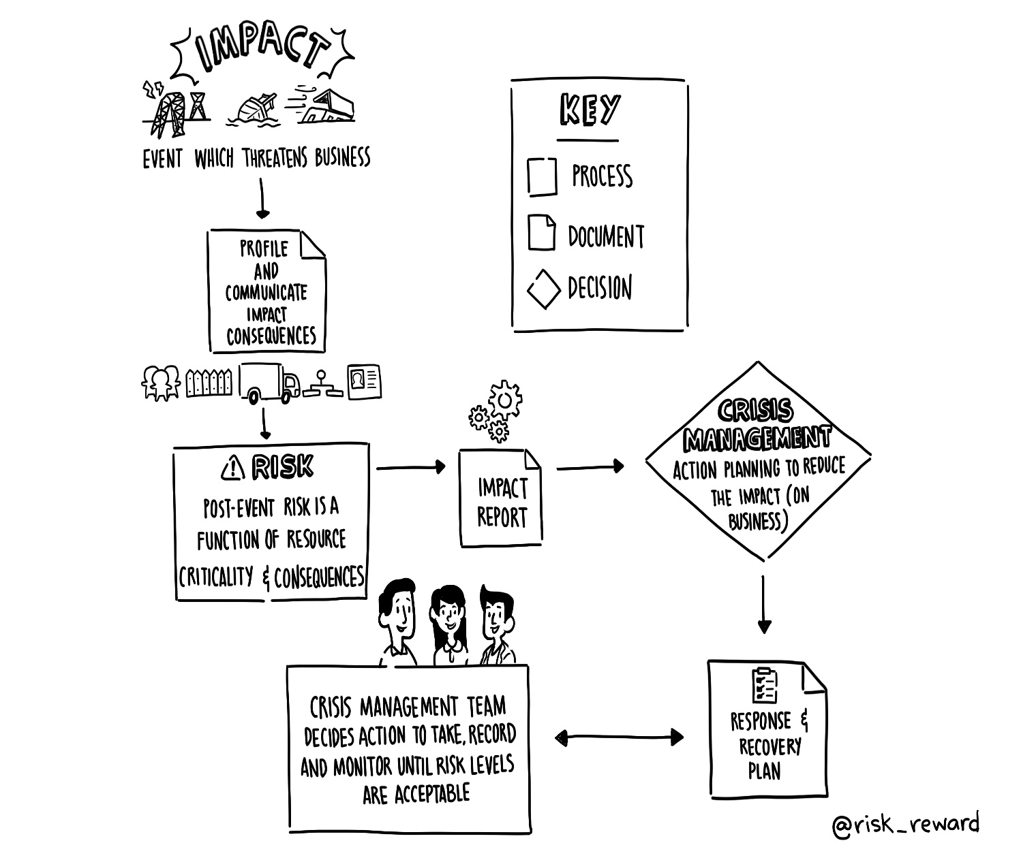

Phase | Objectives | Strategies
1. Initial Response | Assess the event.  Minimize impact where safe and possible to do so.  Communicate the scope of the event to any available member of the Senior Leadership Team.  (0 to 1 Hour) | Staff in the proximity assess the event in terms of risk and impact
1. Initial Response |  | Staff in the proximity provide an immediate response to the event if it is safe to do so and they are competent to do so. This may take the form of standard procedures.
1. Initial Response |  | If an initial assessment of the event and its impact indicates a situation which significantly threatens continuity of business, staff in the proximity should communicate effectively within the organisation by informing (a) any managers of effected Key Business Processes; and (b) any available member of the Crisis Management Team.  Any available member of the Crisis Management Team who judges the nature of the information received is significant enough to “declare an event” should do so, thereby invoking full mobilization of the Crisis Management Team and the Continuity Arrangements (Phase 2 below).
1. Initial Response | Communicate the impact of the event on key functions or business processes to the Crisis Management Team  (0 to 2 Hours) | People responsible for key functions or key business processes start contingency actions and provide any available member of the Crisis Management Team with an initial Impact Assessment Report.

Phase | Objectives | Strategies
2. Continuity - Crisis Management Arrangements | Determine functions affected.  Review resources required.  Review expenditure required.  Prioritize recovery.  Develop an endorsed Action Plan addressing restoration of service objectives (Recovery Time Objectives).  Develop a Master List of Action Plans incorporating an implementation schedule and status reporting schedule.  Communicate the management of the event.  (0 to 24 Hours) | Communicate effectively within the organisation
2. Continuity - Crisis Management Arrangements |  | Develop Action Plans based on ongoing Impact Assessment Reports | If the event has impacts beyond the organisation then this should be factored into decision making at this stage.  The Crisis Management Team will need to resource agreed priority business services and consider how it will release and support staff effected by the broader emergency.
2. Continuity - Crisis Management Arrangements |  | Develop a Master Action Plan List
2. Continuity - Crisis Management Arrangements |  | Advise external stakeholders, customers and if appropriate, affected Government Agencies.
2. Continuity - Crisis Management Arrangements |  | Manage any media communications as necessary.
2. Continuity - Crisis Management Arrangements | Maintain critical services to customers using adjusted resource allocation and temporary methods.  (Within MAO time) | Maintain (and revise) the Action Plans based on updated Impact Assessments (Resource Criticality, Vulnerability and Impact). (These assessments should be updated - and communicated - whenever circumstances change.)
2. Continuity - Crisis Management Arrangements |  | Provide alternative sites and providers as necessary.
2. Continuity - Crisis Management Arrangements |  | Undertake repairs.
2. Continuity - Crisis Management Arrangements |  | Impose temporary service restrictions as necessary.  (Communicate to support the above strategies)
3. Recovery | Complete repairs and/or replacements of resources to agreed standards.  Stand down teams. | Undertake final repair/replacement Action Plans regarding resources.
3. Recovery |  | Stand down all teams (this may need to be phased).
4. Review | Improve Management capability. | Review effectiveness of response to the event by conducting an organisation debrief.

Supporting documentation
Attach supporting documentation in relation to this plan.
The attached documents include:
[List any other documents specifically relevant to your context here.]

